**Chapter 4**

**4.1. Product Backlog**

|  |  |
| --- | --- |
| US1 | As a user ,I want to scan a plant through a camera |
| US2 | As a user, I want to be able to identify the plant by image |
| US3 | As a user, I can get information about the plant |
| US4 | As a user ,I can create an account |
| US5 | As a user ,I can log in to the system with my username and password |
| US6 | As a user, I can set a water reminder for the plant |
| US7 | As a user, I can add products to the e-store |
| US8 | As a user, I can buy products from the e-store |

**4.2. Sprint Backlog**

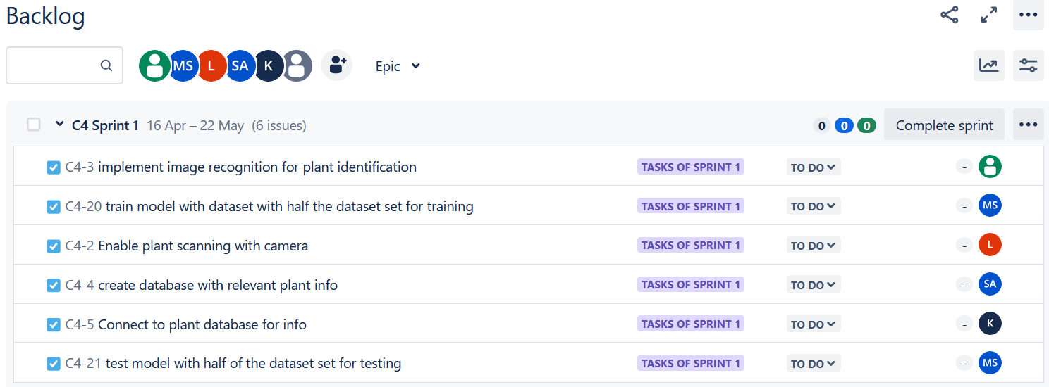

**4.3. Tasks and Their Allocation**

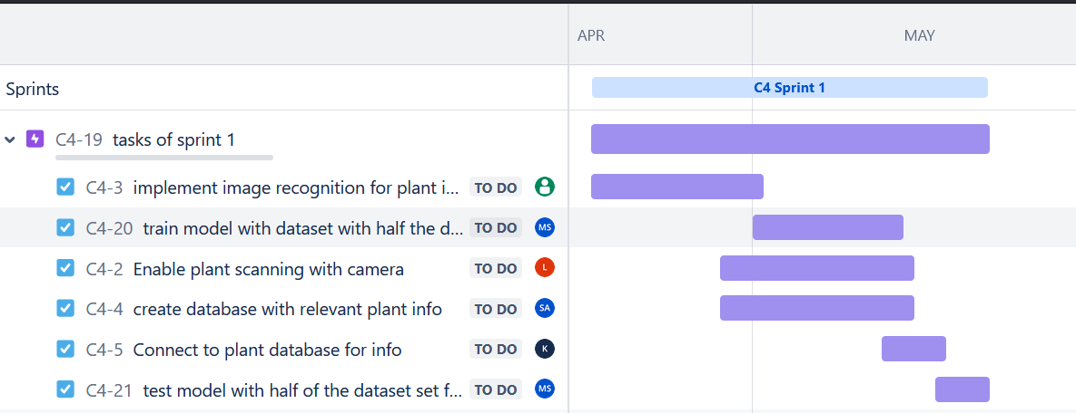

**4.4. Burndown Chart**

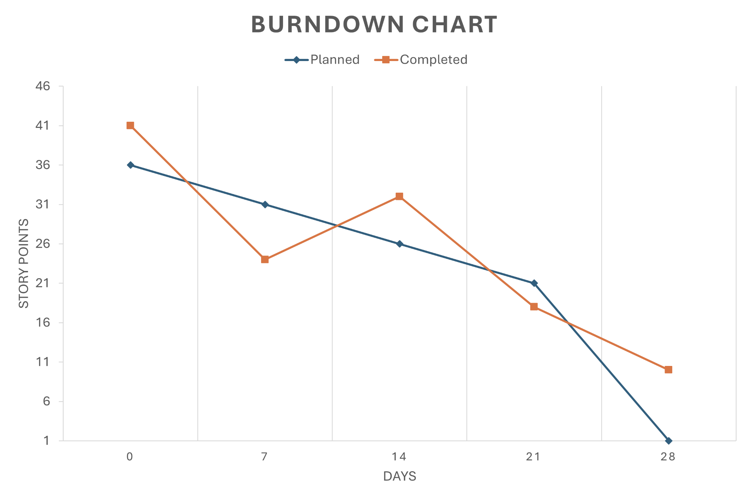

**4.5. Conclusion**

We established the foundation for our project's development by delineating the product backlog. This comprehensive inventory encapsulates the essential user stories, through this meticulous planning, we've outlined the core features necessary for our system's functionality.

Furthermore, we introduced the sprint backlog, breaking down the user stories into specific tasks allocated to team members. This strategic approach ensures an organized development process, fostering collaboration and accountability within the team.

Additionally, we emphasized the importance of tracking progress through the burndown chart, enabling us to monitor our development velocity and make necessary adjustments to ensure project success.